We have used confusion matrix and accuracy as out performance measures for the classification task. We have used LOSO – Leave One Subject Out strategy to test/train our models. Out of total 92 subjects, a model is trained on 91 subjects and tested on 1 subject. Total of 92 models are trained/tested and mean of the results is shown below in the confusion matrix.

There are total of six classes : Anger, Disgust, Fear, Happy, Neutral, and Sad.

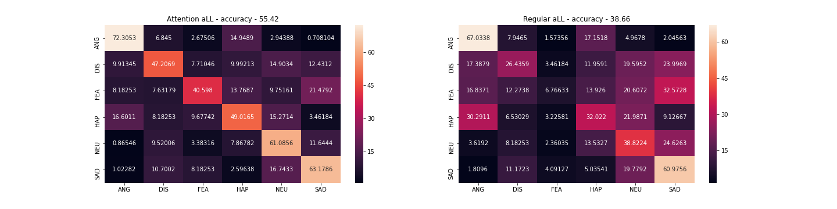

The confusion matrix on the left shows the normalized average result of all the models with attention and the confusion matrix on the left shows the normalized average result of all the models without attention with their accuracies listed on top. While the average accuracy of the models without attention averages out at 38.66%, the models with attention significantly surpasses the average accuracy to 55.42% given they are trained for same amount of time and with same parameters.

The diagram below visualizes the input given to the model. The image on the left shows the focused area where the attention model pays attention and the one on the left shows the one without any attention.

